**No exceptions! You must show all work and/or explain your answers to receive full credit.**

**( 10 points)**

Please Note : It is recommended that you print and write out your answers. Scan/take a photo and upload to the drop-box in Unit 6, Lesson 9 Slide 3. (You may use extra paper as needed – make sure it is uploaded as well.)

**Lesson 4-1.** *Given that SAT ≅ GRE, complete the congruence statement***.**

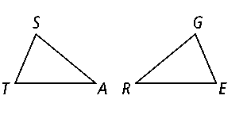

1. ******≅** _____________
2. **≅** _____________

**Lesson 4-2 and 4-3.** *Can you prove the two triangles congruent? If so, write the congruence statement and name the postulate you would use. If not, write not possible and tell what other information you would need.*

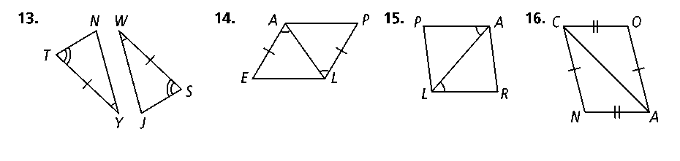



1. 5.

**Lesson 4-4.** *Write a proof. ( 3 points)*

6. **Given:** *PO* = *QO*, ∠1  ∠2, **prove:** ∠*A*  ∠*B*

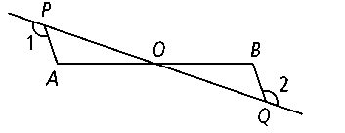

**Lesson 4-5**. *Find the value of all variables.*

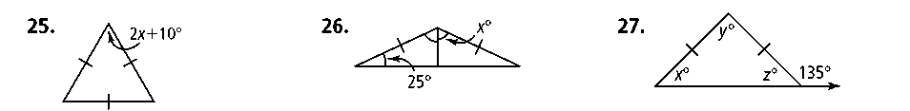7.

**Lesson 4-6 and 4-7.** *Name a pair of overlapping congruent triangles in the diagram. State whether the triangles are congruent by SSS, SAS, ASA, AAS, or HL.*

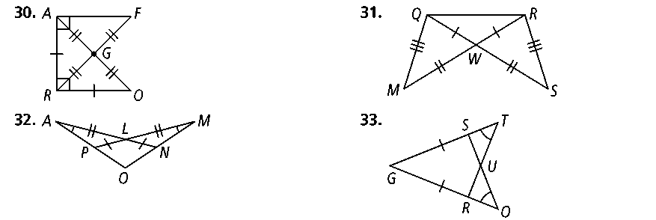

8.